**Lab report - 03**

*Course title: Computer Graphics Laboratory*

*Course code: CSE-304*

*3rd Year 1st Semester 2022*

**Date of Submission**: 11/06/2023



**Submitted to-**

Dr. Mohammad Shorif Uddin (Professor)

Dr. Morium Akter (Associate Professor)

*Department of Computer Science and Engineering*

*Jahangirnagar University*

*Savar, Dhaka-1342*

|  |  |  |
| --- | --- | --- |
| **Name** | **Class roll** | **Exam roll** |
| Hasneen Tamanna Totinee | 362 | 202174 |

**1. Scan converting a line object from (0,0) to (100,50) and**

**i. rotate it by 30o**

**ii. scale it to 50%**

**iii. translate it on x-axis by 75 pixels**

Code:

#include<iostream>  
#include<graphics.h>  
#include<math.h>  
using namespace std;  
int main()  
{  
    int gd = DETECT,gm;  
    initgraph(&gd,&gm,"");  
  
    int x1=0,y1=0,x2=100,y2=50;  
    /*int centerX = x1+(x2-x1)/2;  
    int centerY = y1+(y2-y1)/2;*/  
    line(x1,y1,x2,y2);  
    float angle = 30* 3.14158/180;  
    int x1_rotated = (x1)*cos(angle)-(y1)*sin(angle);  
    int y1_rotated =(x1)*sin(angle)+(y1)*cos(angle);  
    int x2_rotated = (x2)*cos(angle)-(y2)*sin(angle);  
    int y2_rotated = (x2)*sin(angle)+(y2)*cos(angle);  
    setcolor(BLUE);  
    line(x1_rotated,y1_rotated,x2_rotated,y2_rotated);  
  
    int x1_scaled = x1 * 0.5;  
    int y1_scaled = y1 * 0.5;  
    int x2_scaled = x2 * 0.5;  
    int y2_scaled = y2 * 0.5;  
  setcolor(RED);  
    line(x1_scaled,y1_scaled,x2_scaled,y2_scaled);  
  
    int x1_translated = x1 + 75;  
    int y1_translated = y1;  
    int x2_translated = x2 + 75;  
    int y2_translated = y2;  
    setcolor(GREEN);  
    line(x1_translated,y1_translated,x2_translated,y2_translated);  
    getch();  
    closegraph();  
}

Output:

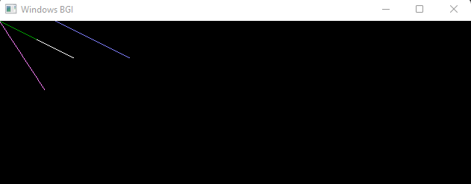

**2. Draw a kite using Bresenham’s line algorithm**

Code:

#include <bits/stdc++.h>

#include<graphics.h>

using namespace std;

void drawLine(int x1, int y1, int x2, int y2)

{

int dx = abs(x2 - x1);

int dy = abs(y2 - y1);

int sx = (x1 < x2) ? 1 : -1;

int sy = (y1 < y2) ? 1 : -1;

int err = dx - dy;

while (true)

{

//cout << "(" << x1 << ", " << y1 << ")\n";

putpixel(x1,y1,WHITE);

putpixel(x2,y2,WHITE);

if (x1 == x2 && y1 == y2)

{

break;

}

///etuk e ki koreche?

int e2 = 2 * err;

if (e2 > -dy)

{

err -= dy;

x1 += sx;

}

if (e2 < dx)

{

err += dx;

y1 += sy;

}

}

}

void drawKite()

{

int width = 100; // width of the kite

int height = 200; // height of the kite

int x1 = 0;

int y1 = height / 2;

int x2 = width / 2;

int y2 = 0;

int x3 = width;

int y3 = height / 2;

int x4 = width / 2;

int y4 = height;

int x5 = width/2;

int y5 = height/2;

drawLine(x1, y1, x2, y2);

drawLine(x2, y2, x3, y3);

drawLine(x3, y3, x4, y4);

drawLine(x4, y4, x1, y1);

drawLine(x1, y1, x5, y5);

drawLine(x2, y2, x5, y5);

drawLine(x3, y3, x5, y5);

drawLine(x4, y4, x5, y5);

}

int main()

{

int gd=DETECT,gm;

initgraph(&gd,&gm,"");

drawKite();

getch();

closegraph();

return 0;

}

Output:

